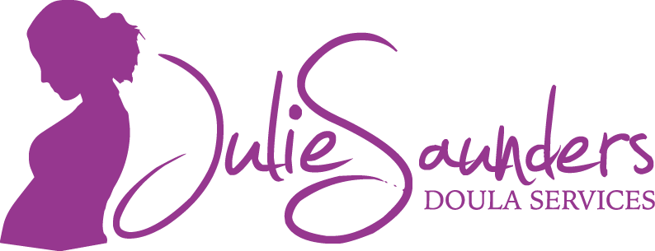

What to pack for the hospital
Please check with your hospital for items that may be avaliable to you.

For MOM:
- Insurance and health benefit information
- pillows/blanket
- birth plan
-pads
-bottom spray (earth momma angel spray)
-nightgown/PJ's (nightgown that can open from the front is great for skin to skin)
- slippers
- hair elastics
-lip balm
- snacks/drinks
- lotion
-toothbrush/toothpaste
-washcloths
-birthing ball
-straws
-music
-massage oil
-warm socks (non skid socks are great)
-maternity bras, nursing pads
-bath towel

For DAD:
-extra clothes
-snacks/drinks
-pillow/blanket
-cell phone/charger
- birth plan
-contact numbers of people you with to celebrate with
-camera
-pen/paper to take3 notes
-change for vending machines

For BABY:
-diapers
-wipes
-onesies
-sleepers
-going home outfit
-hats
-bum cream
-car seat
- recieving blankets
-wash cloths
-blankets
-container for placenta if taking it.

